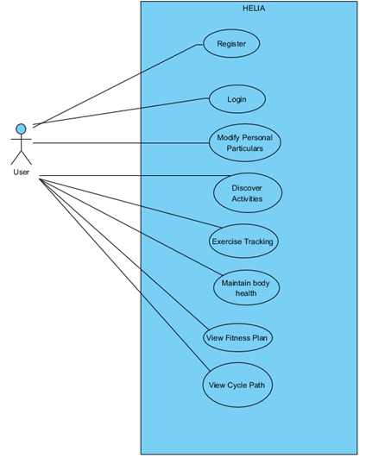

|  |  |
| --- | --- |
| **Use Case ID** | UC - 01 |
| **Use Case Name** | Register |
| **Use Case**  **Description** | Allows Helia Users that do not have an account to create an account |
| **Participating**  **Actor(s)** | User |
| **Pre-Conditions** | 1. The User must not have an account 2. The User must not be logged in |
| **Post-Conditions** | 1. The User has created an account |
| **Normal Flow** | * 1. The User fill in his Username, Password, Email, and other personal information and   2. The User press the Register button   3. The System checks if the Username and Email has been taken   AF-1: The Username has been taken  AF-2: The Email has been taken   * 1. The System saves the User information into the database |
| **Alternative Flows** | AF-1: The Username has been taken   1. The System prompts the User that the Username has been taken. 2. The User acknowledge and is taken back to 1.3   AF-2: The Email has been taken   1. The System prompts the User that the Email has been used. 2. The User acknowledge and is taken back to 1.3 |
| **Exceptions** | - |
| **Includes** | - |

|  |  |
| --- | --- |
| **Use Case ID** | UC – 02 |
| **Use Case Name** | Login |
| **Use Case**  **Description** | Allows Helia Users login to their account |
| **Participating**  **Actor(s)** | User |
| **Pre-Conditions** | 1. The User must have an account 2. The User must not be logged in |
| **Post-Conditions** | 1. The User is logged in |
| **Normal Flow** | * 1. The User enters his Username and Password   2. The User press the Login button   3. The System checks if the Username and Password matches in the database   AF-1: The Username does not exist  AF-2: The Password is incorrect   * 1. The System logs the user in |
| **Alternative Flows** | AF-1: The Username does not exist   1. The System prompts the User that the Username does not exist. 2. The User acknowledge and is taken back to 1.1   AF-2: The Password is incorrect   1. The System prompts the User that the Password is incorrect. 2. The User acknowledge and is taken back to 1.1 |
| **Exceptions** | - |
| **Includes** | - |

|  |  |
| --- | --- |
| **Use Case ID** | UC – 03 |
| **Use Case Name** | Modify Personal Particulars |
| **Use Case**  **Description** | Allows Helia Users to modify their particulars |
| **Participating**  **Actor(s)** | User |
| **Pre-Conditions** | 1. The User is logged in |
| **Post-Conditions** | 1. The User information is saved |
| **Normal Flow** | * 1. The User change any details of his particulars   2. The User press the Save button   3. The System checks for any invalid input   AF-1: There are invalid inputs   * 1. The System save the changes made |
| **Alternative Flows** | AF-1: There are invalid inputs   1. The System prompts the User of the invalid input 2. The User acknowledge and is taken back to 1.1 |
| **Exceptions** | - |
| **Includes** | - |

|  |  |
| --- | --- |
| **Use Case ID** | UC – 04 |
| **Use Case Name** | Discover Activities |
| **Use Case**  **Description** | Allows Helia Users to discover various activities to promote a healthier lifestyle |
| **Participating**  **Actor(s)** | User |
| **Pre-Conditions** | 1. The User is logged in |
| **Post-Conditions** | 1. A list of activities will be displayed |
| **Normal Flow** | * 1. The User clicks on the Discover Activities button   2. The System checks the User’s preference, the current weather condition and matches it with the list of activities.   3. The System displays the activities that would be appropriate for the user |
| **Alternative Flows** | - |
| **Exceptions** | - |
| **Includes** | - |

|  |  |
| --- | --- |
| **Use Case ID** | UC – 05 |
| **Use Case Name** | Exercise Tracking |
| **Use Case**  **Description** | Allows Helia Users to keep track of the exercises they’ve done |
| **Participating**  **Actor(s)** | User |
| **Pre-Conditions** | 1. The User is logged in |
| **Post-Conditions** | 1. Their exercise done will be saved |
| **Normal Flow** | * 1. The User clicks on the Exercise Tracking button   2. The System checks the Users exercises and display the Users past exercise and the trend   3. The User enters the detail of his exercise and clicks on the submit button   4. The System validate the information entered   AF-1: The information is invalid   * 1. The System saves the exercise |
| **Alternative Flows** | AF-1: The information is invalid   1. The System prompts the User of the invalid information 2. The User acknowledge and is taken back to 1.3 |
| **Exceptions** | - |
| **Includes** | - |

|  |  |
| --- | --- |
| **Use Case ID** | UC – 06 |
| **Use Case Name** | Maintain Body Health |
| **Use Case**  **Description** | Allows Helia Users to view their current health condition and track their food and water consumption |
| **Participating**  **Actor(s)** | User |
| **Pre-Conditions** | 1. The User is logged in 2. The User must have entered their Height, Weight and Age in their Profile |
| **Post-Conditions** | 1. The System will show the trend of the meal that the User have taken 2. The System will save the meal that the User has taken |
| **Normal Flow** | * 1. The User clicks on the Body Health button   1.2 The System checks for the data that the User has saved along with their body mass index (BMI) and display them  1.3 The User enters the detail of his meal and clicks on the submit button  1.4The System validate the information entered  AF-1: The information is invalid  1.5The System saves the meal |
| **Alternative Flows** | AF-1: The information is invalid   1. The System prompts the User of the invalid information 2. The User acknowledge and is taken back to 1.3 |
| **Exceptions** | - |
| **Includes** | - |

|  |  |
| --- | --- |
| **Use Case ID** | UC – 07 |
| **Use Case Name** | View Fitness Plan |
| **Use Case**  **Description** | Allows Helia Users to view their suggested Fitness Plan base on their BMI and past exercise data. |
| **Participating**  **Actor(s)** | User |
| **Pre-Conditions** | 1. The User is logged in 2. The User must have entered their Height, Weight and Age in their Profile |
| **Post-Conditions** | 1. The User will be able to view their Fitness Plan |
| **Normal Flow** | * 1. The User clicks on the Fitness Plan Button   2. The System checks the User BMI and allocate a weekly fitness plan for them   3. The System checks for any exercise done during the week and match them with the fitness plan   4. The System displays the fitness plan that has been marked for the User to see |
| **Alternative Flows** | - |
| **Exceptions** | - |
| **Includes** | - |

|  |  |
| --- | --- |
| **Use Case ID** | UC – 08 |
| **Use Case Name** | View Cycle Path |
| **Use Case**  **Description** | Allows Helia Users to view their suggested Fitness Plan base on their BMI and past exercise data. |
| **Participating**  **Actor(s)** | User |
| **Pre-Conditions** | 1. The User is logged in 2. The User must have their GPS turned on |
| **Post-Conditions** | 1. The User will be able to view the Cycle Path base on their current location |
| **Normal Flow** | * 1. The User clicks on the Cycle Path Button   2. The System checks the User current location and list out the nearby cycle path   AF-1: The User GPS is not turned on   * 1. The System displays the cycle path along with the User location for the User to see |
| **Alternative Flows** | AF-1: The User GPS is not turned on   1. The System prompts the User to turn on their GPS 2. The User turns their GPS on and is taken back to 1.2 |
| **Exceptions** | - |
| **Includes** | - |